

**Advanced Python (MCA 372A)**

**ESE -01**

***BY***

**VANSHAJ P MOHAN (24225029)**

**SUBMITTED TO**

**Prof. Manjula Shnabhog**

**SCHOOL OF SCIENCES**

**2024-2025**

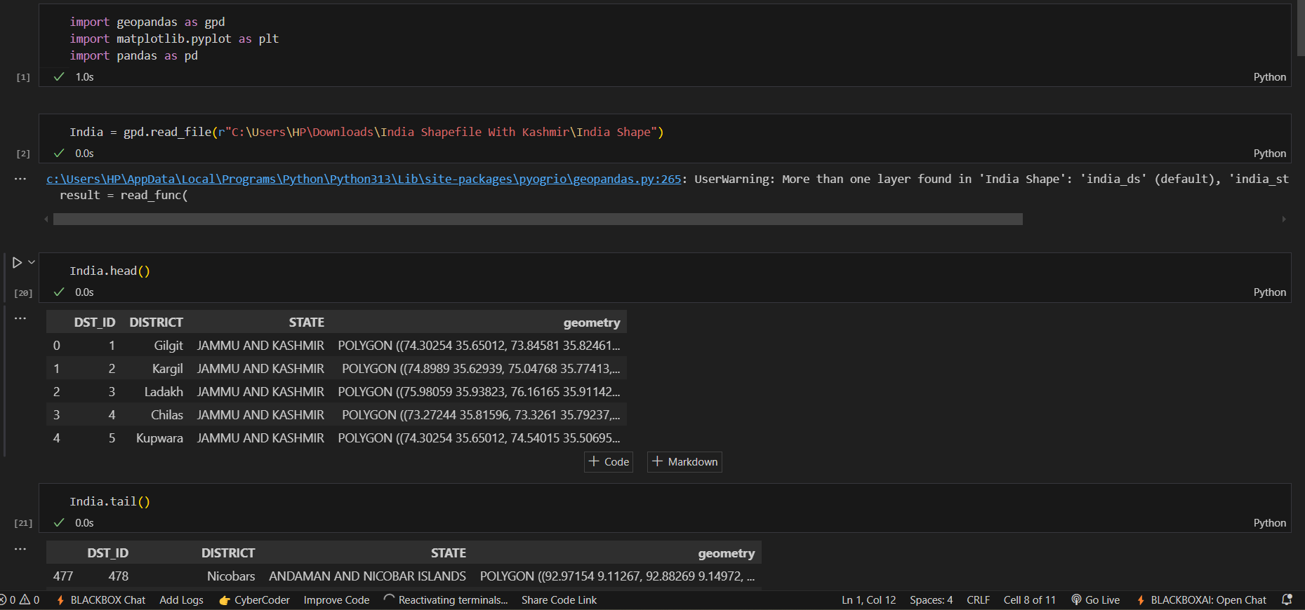

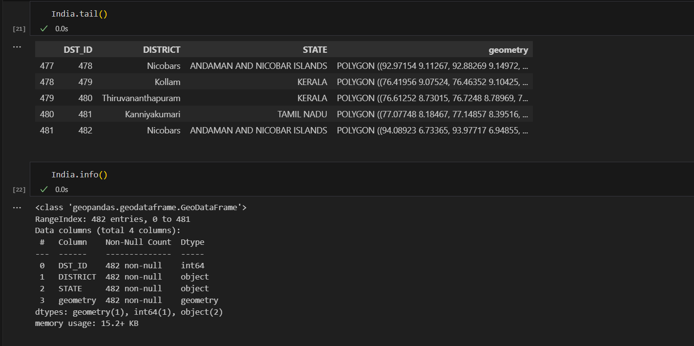

QUESTION 1:

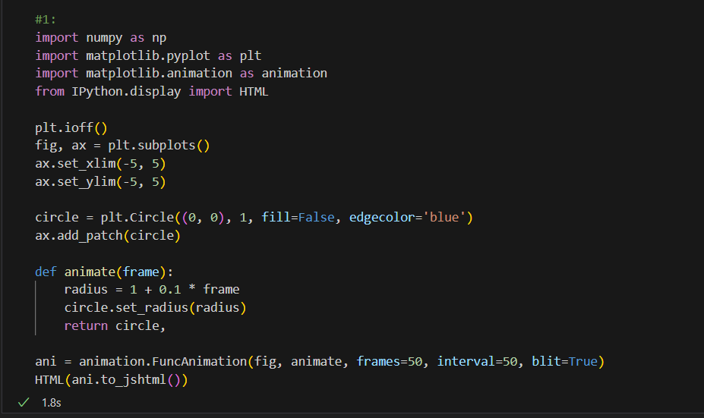

OUTPUT:

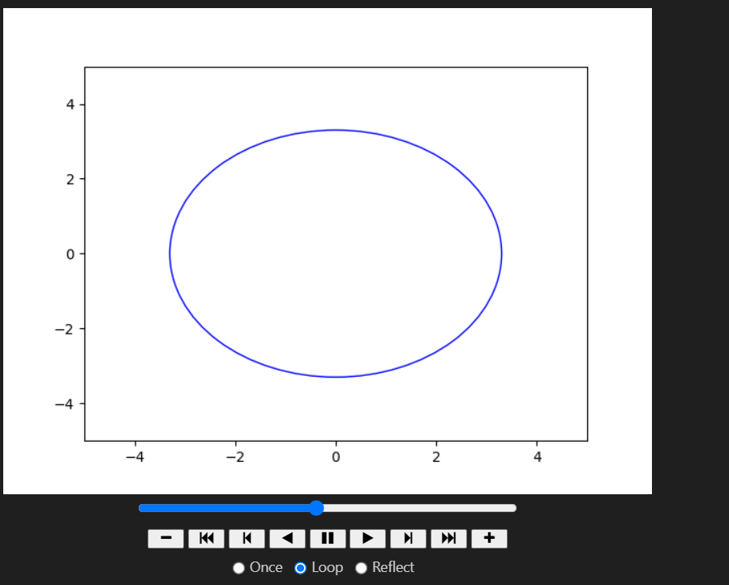

QUESTION 2:

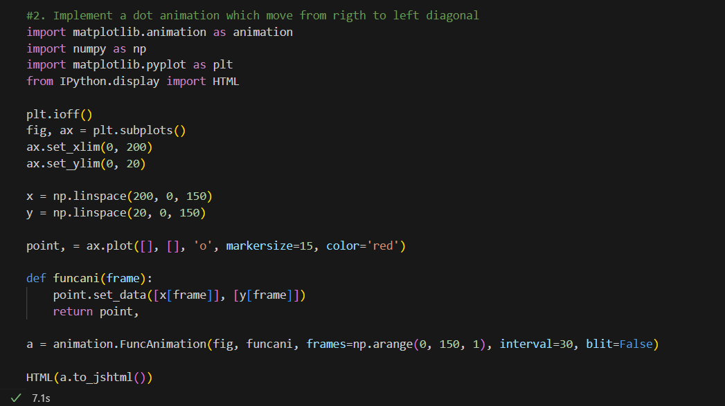

OUTPUT:

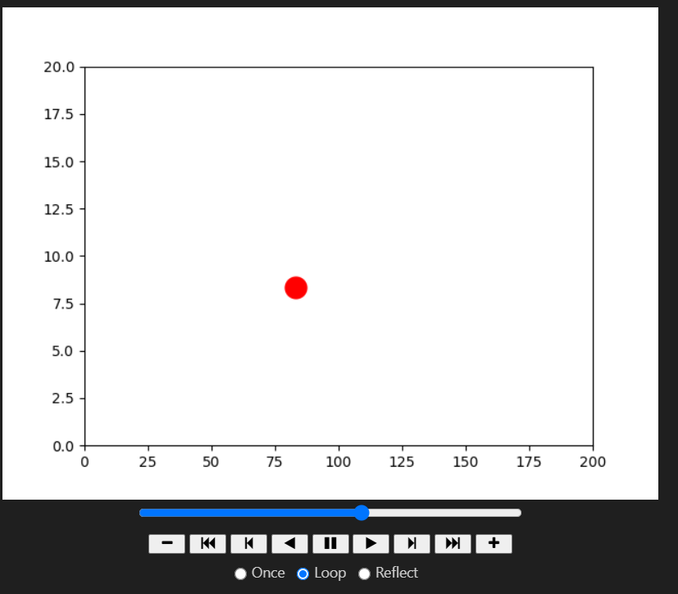

QUESTION 3:

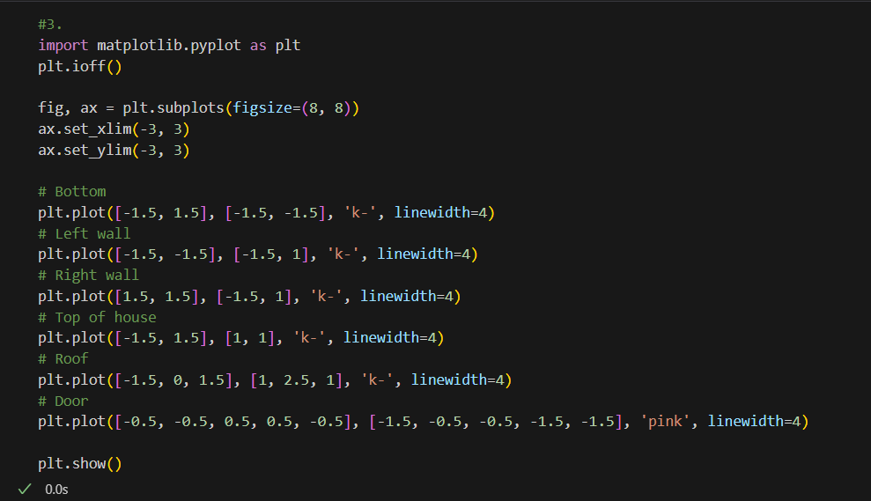

OUTPUT:  
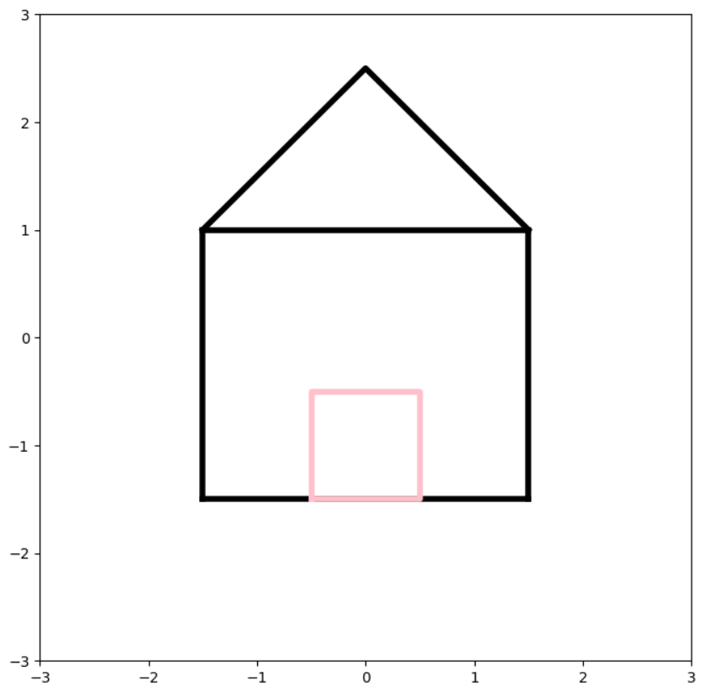

QUESTION 4:

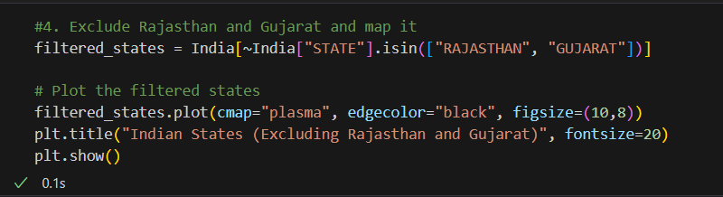

OUTPUT:

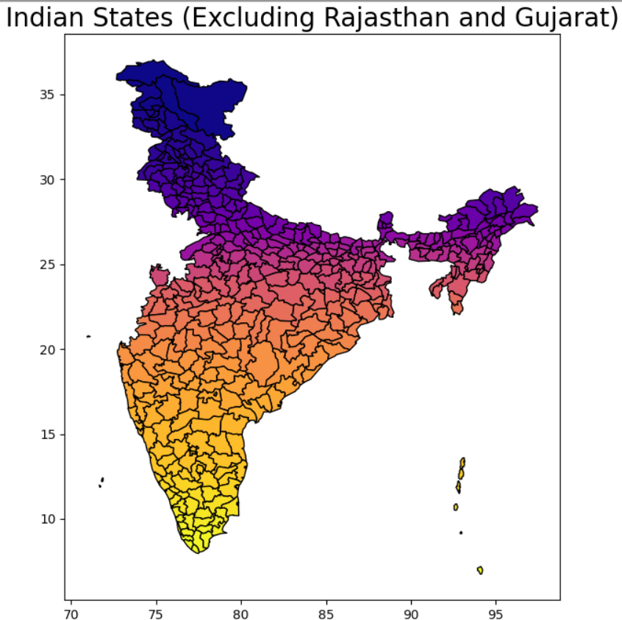

QUESTION 5:

